London, 29 September 2014

UAE economy grows stronger thanks to effective diversification policy

- 5% growth projected for 2014 on the back of successful diversification policy
- Favourable business environment, supported by new company law to improve transparency
- Debt profile improves. Financing needs of government-related entities (GRE) continues to be a question

In its latest country assessment, Coface has ranked the United Arab Emirates (UAE) A3 , and expects the country’s enonomy to grow by around 5 percent in 2014. The business climate in the UAE has also been assessed at A3, taking into account a number of factors such as the availability of company reports, reliability and the effectiveness of the legal system. After contracting by around 5 percent in 2009, the UAE’s economy has recovered gradually to register solid growth rates, with 5.2 percent recorded in 2013.

“The UAE economy remains solid, supported by both the oil and gas sector and non-oil sector. The country’s diversification policy constitutes an important pillar of its economic performance, as it reduces its dependence on oil and supports the real economy. The business environment is improving and the actions taken to increase transparency within the economy are crucial to reducing risks in the corporate sector,” said Seltem Iyigun, Economist for the MENA at Coface.

Economic growth performance
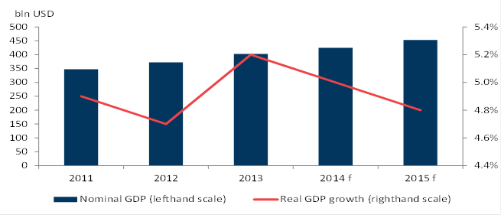

Earlier this year, Dubai managed to refinance its maturing debt (around USD 20 billion) with Abu Dhabi and the UAE central bank, under favourable conditions. However, the debt burden of the entire public sector in Dubai is still heavy, with significant amounts becoming due in the next few years (almost 40 billion USD between 2015 and 2017).

The introduction of regulatory measures by the authorities, aimed at avoiding another real estate bubble, is also promising for the country’s economy. In addition, the introduction of a new company law, which will gradually reform corporate governance, is seen as major progress. However, there is still room for improvement, as company financial accounts are rarely available - with the exception of those of large international groups.

Oil sector: key contributor to the growth

The UAE produces 3.5 percent of the world’s crude oil, representing 7 percent of proven reserves, and is ranked 7th in the world and 4th within the OPEC countries. In 2013, the oil sector accounted for one-third of GDP and oil exports were approximately one-third of total exports. The UAE’s public finances remain highly dependent on oil revenues, despite on-going diversification of the economy. Oil accounted for almost 80 percent of fiscal revenues in 2013. The main risks in this sector is the dependence of corporate profitability on government subsidies and the balancing of the country’s oil supply and demand. Regional conflicts may also represent a source of risk.

Agro-food sector: heavy dependence on imports

The agro-food sector is becoming increasingly important in the UAE, in line with the growing population and per capita income. The country accounts for 20% of the total food consumption of the Gulf Cooperation Council (GCC) countries, where it is the second largest consumer after Saudi Arabia. The country is also the second largest food producer in the GCC. However, there is limited arable land and the climate is not very favourable to agriculture. The government supports the agricultural sector and food processing industry. Heavy dependence on food imports creates a risk for the country if there is a shortage in food supply. The government’s control over food prices may also weigh negatively on corporate profit margins.

Retail sector: favourable environment for expansion, with limited risks

Retail is one of the fastest-growing sectors in the UAE, supported by increasing wealth, economic sustainability and strong domestic consumption. The fact that the UAE was not affected by the political turmoil in the Arab World made the country a more popular tourism destination, which in turn also contributed to the expansion of the retail sector. Intense competition and price increases in accommodation, food, transport, education and rent can be considered as major risks weighing on retail activity - but these risks remain limited.

“Our report confirms that the region’s economy has developed significantly over the past three years, establishing it as a leading global trading economy. Non-oil trade reached 256 billion AED during the first quarter of 2014, showing continued momentum driven by the country’s non-oil foreign trade in all economic sectors - as reported by UAE Federal Customs Authority. The UAE represents an ideal business location and a safe haven in the Middle East Region”, said Massimo Falcioni, Head of the Middle East region within, Coface.

ENDS

MEDIA CONTACT:
Trevor Byrne
Tel: +44 (0)1923 478393
Email: trevor.byrne@coface.com
Website: www.cofaceuk.com

About Coface

The Coface Group, a worldwide leader in credit insurance, offers companies around the globe solutions to protect them against the risk of financial default of their clients, both on the domestic market and for export. In 2013, the Group, supported by its 4,440 staff, posted a consolidated turnover of €1.440 billion. Present directly or indirectly in 98 countries, it secures transactions of over 37,000 companies in more than 200 countries. Each quarter, Coface publishes its assessments of country risk for 160 countries, based on its unique knowledge of companies’ payment behaviour and on the expertise of its 350 underwriters located close to clients and their debtors.
In France, Coface manages export public guarantees on behalf of the French State.
www.coface.com

Coface SA. is listed on Euronext Paris – Compartment A
ISIN: FR0010667147 / Ticker: COFA

In the UK and Republic of Ireland Coface has been a leading provider of credit management services
since 1993 - its objective being to enable businesses to trade securely at home and overseas. Operating
from offices in London, Dublin, Watford, Birmingham, Manchester and Cardiff allows Coface to provide a
local service.

The company’s credit insurance offer integrates credit assessment, collection services and cover for
unpaid debts. Multinational businesses can protect their worldwide subsidiaries through Coface’s international network.

The company also provides access to domestic and international business information and a collection
network at home and overseas. Coface is also a recognised operator in the London political risk market.

www.cofaceuk.com and www.coface.ie

Coface uses a seven-level ranking. In ascending order of risk, these are: A1, A2, A3, A4, B, C and D. The country assessment provides an insight into the average payment incident level presented by companies in a country, in connection with their short term trading transactions.

